TALOSEC SOC DAILY INCIDENT REPORT

Incident Identification
- Organization: Talosec
- Case Tracking Code: CORD-202512-AliRayyan-001
- Incident Type:
  - SSH Failed Login Attempts
  - Post-Mitigation Suspicious Network Activity
- Incident Status: Mitigation Active – Monitoring Ongoing
- Reported By: SOC Analyst Intern
- Analysis Period: Past 24 Hours
- Affected Asset: server02
- Wazuh Version: 4.14.1

1. Executive Summary
During the past 24 hours, server02 generated a total of 86 security alerts.
Of these, 12 alerts were related to SSH failed login attempts using non-existent usernames, while the remaining alerts were system and mitigation-related events.
Firewall-drop Active Response continues to operate as expected, automatically blocking offending IP addresses. A single external source IP exhibited limited multi-port access, which was analysed and determined not to be network port scanning, but rather evasive SSH brute-force behaviour.
No successful authentication or system compromise was detected.

2. Incident Description
The environment remains under low-level background attack activity, primarily consisting of automated SSH login attempts. Defensive controls are successfully preventing sustained or high-volume attacks.

3. SSH Failed Login Activity
Detection Details
- Primary Rule Triggered: 5710 – SSH Attempt to Login Using Non-Existent User
- Total SSH Alerts: 12
- Attack Behaviour:
  - Failed authentication attempts
  - Automatic IP blocking via firewall-drop
  - Repeat attempts observed only after unblock timeout
Analysis
The low number of SSH failed login attempts indicates that Active Response is effectively suppressing brute-force activity. Attackers are unable to maintain persistence due to immediate blocking.
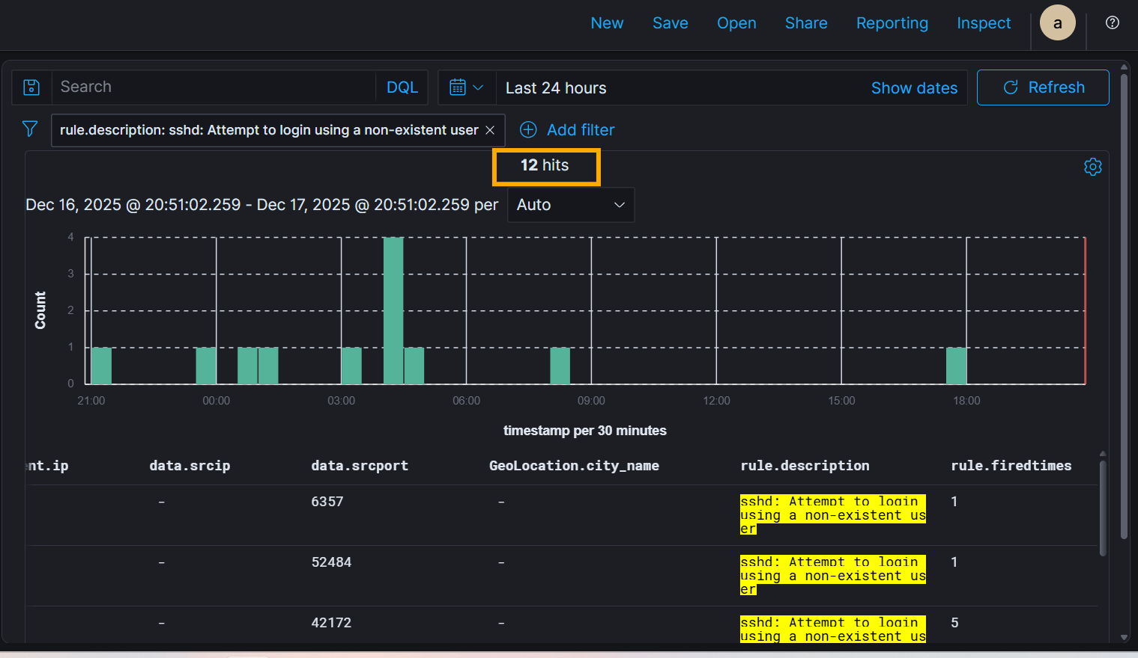
Conclusion
This activity is classified as Low-Volume Automated SSH Brute-Force Attempts, successfully mitigated.

4. Post-Mitigation Multi-Port Activity Analysis
Observed Behavior
A single external source IP (39.152.6.7) accessed four distinct high-numbered ports:
- 42450 – 1 attempt
- 45440 – 1 attempt
- 46120 – 1 attempt
- 46698 – 1 attempt
Attempts were isolated and distributed across time.
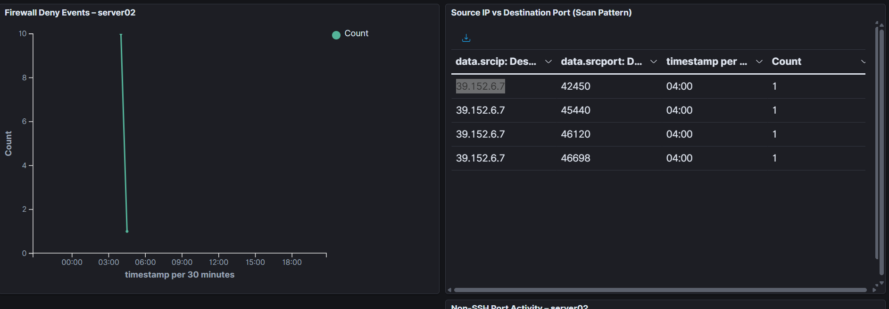
Analysis
This behavior does not meet the criteria for network port scanning:
- Only four ports accessed
- No sequential or systematic probing
- Very low attempt frequency
- Activity remains correlated with SSH-related events
The pattern aligns with evasive SSH brute-force techniques, where attackers vary connection parameters to bypass detection.
Conclusion
The activity is assessed as evasive SSH brute-force behavior, not reconnaissance or port scanning.

5. Mitigation Effectiveness
- Firewall-drop Active Response: Enabled and operational
- Result: Offending IPs blocked automatically
- Alert Volume: Maintained at low levels
- Effectiveness: High
Active Response continues to significantly reduce attack surface exposure.

6. Impact Assessment
- System Availability: Not impacted
- Data Confidentiality: No evidence of compromise
- Data Integrity: Maintained
- Overall Risk Level: Low (Mitigated)

7. Recommendations
- Maintain firewall-drop Active Response for SSH alerts.
- Increase block duration for repeat offenders if activity persists.
- Enforce SSH key-based authentication where possible.
- Continue monitoring for:
  - Successful logins
  - Privilege escalation
  - Lateral movement indicators

8. Incident Status
Current Status: Mitigation Active – Monitoring Ongoing
No escalation required at this time.

9. Closing Statement
Security controls are functioning as intended, with a substantial reduction in malicious activity and no indication of compromise. The environment remains stable under continuous SOC monitoring.

